AI-DRIVEN DIGITAL TWIN OF THE
ISS POWER–THERMAL–LIFE SUPPORT SYSTEM

Project Report

Submitted by
SE TAMIL SELVAN - Electrical Engineering

ABSTRACT

The International Space Station (ISS) operates in a highly dynamic orbital environment where power availability, battery reliability, and thermal stability are critical for mission safety. Periodic sunlight exposure and eclipse cycles create continuous variations in energy generation, causing stress on battery systems and thermal subsystems. Accurate monitoring of internal states such as State of Charge (SOC), core temperature, and battery health is essential for ensuring safe and uninterrupted operation.

This project presents an AI-driven Digital Twin framework designed to model, estimate, and protect an ISS-inspired power–thermal system. A multi-state Kalman filtering approach is implemented to estimate hidden system states under noisy sensor measurements and orbital disturbances. The digital twin reconstructs true SOC, core temperature, and health degradation parameters in real time.

To enhance system reliability, a statistical anomaly detection mechanism based on Normalized Innovation Squared (NIS) analysis is incorporated. Residual monitoring enables early detection of abnormal behavior, and an autonomous protective mode is activated when anomalies exceed predefined thresholds. Fault injection experiments validate the robustness of the detection and protection mechanism.

Simulation results demonstrate strong estimation accuracy with SOC RMSE of 0.009780 and health RMSE of 0.000225. The filter consistency is validated with an average NIS value close to theoretical expectations, confirming stable and reliable performance.

The developed digital twin demonstrates an intelligent monitoring and protection architecture applicable to spacecraft power systems, satellite battery management, and high-reliability energy storage applications. This work establishes a strong foundation for advanced autonomous health management systems in space engineering.

INTRODUCTION

The International Space Station (ISS) operates in Low Earth Orbit under continuously changing environmental conditions. One of the most critical subsystems of the ISS is its electrical power and energy storage system. The station relies on solar arrays for energy generation and battery systems for energy storage during eclipse periods when sunlight is unavailable. These orbital sunlight–eclipse cycles create periodic disturbances in power availability, directly influencing battery charging, thermal behavior, and long-term degradation.

In space environments, direct measurement of all internal system states is not always feasible. Parameters such as true State of Charge (SOC), internal core temperature, and battery health degradation cannot be measured with perfect accuracy due to sensor noise, modeling uncertainty, and environmental disturbances. Any failure in monitoring these internal states can lead to reduced performance, overheating, unexpected degradation, or even mission-critical failures.

Modern space systems increasingly require intelligent monitoring mechanisms capable of estimating hidden states, filtering noisy measurements, detecting abnormal behavior, and activating protection autonomously. This is where the concept of a Digital Twin becomes highly relevant. A digital twin is a dynamic virtual representation of a physical system that continuously estimates internal states and predicts system behavior using mathematical models and real-time data.

This project develops an AI-driven Digital Twin for an ISS-inspired power–thermal–health system. The system integrates:
• Orbital disturbance modeling
• Multi-state Kalman filtering
• Statistical consistency validation
• Residual-based anomaly detection
• Autonomous protective mode activation
The developed framework not only estimates internal system states accurately but also ensures reliability through statistical validation and fault detection mechanisms. The objective is to demonstrate an intelligent, autonomous health management

PROBLEM STATEMENT

Space-based power systems operate under extreme environmental and operational constraints. The International Space Station (ISS), for example, experiences periodic sunlight and eclipse cycles due to its orbital motion around Earth. During sunlight exposure, solar panels generate power and charge batteries. During eclipse, the station depends entirely on stored battery energy. This continuous transition between charging and discharging introduces dynamic stress on the battery and thermal subsystems.

Several engineering challenges arise in such an environment:
• Periodic and unpredictable energy disturbances
• Thermal fluctuations due to varying power flow
• Sensor measurement noise
• Inability to directly measure internal battery states
• Risk of undetected degradation or abnormal behavior
• Requirement for autonomous protection

Accurate monitoring of internal states such as State of Charge (SOC), core temperature, and battery health degradation is critical for mission safety. However, these states cannot be measured directly with perfect accuracy. Instead, they must be estimated using mathematical models and noisy sensor measurements.

Additionally, traditional monitoring systems may not detect subtle degradation or statistical inconsistencies until significant damage has occurred. In space missions, delayed fault detection can lead to irreversible system failure.
Therefore, there is a need for an intelligent system capable of:
- Estimating hidden internal states accurately
- Filtering noisy sensor data
- Validating statistical consistency of the estimator
- Detecting anomalies early
- Activating protective mechanisms autonomously
This project addresses these challenges by developing an AI-driven Digital Twin architecture incorporating multi-state Kalman filtering, statistical validation through Normalized Innovation Squared (NIS) analysis, and residual-based anomaly detection with automatic protective mode activation.

SYSTEM ARCHITECTURE

The proposed AI-driven Digital Twin architecture is designed to model, estimate, and protect an ISS-inspired power–thermal–health system operating under orbital disturbances. The architecture integrates disturbance modeling, state estimation, statistical validation, and anomaly detection into a unified intelligent framework.

The overall system structure can be described as follows:
Orbital Environment
→ Sensor Measurement Layer
→ Multi-State Kalman Estimator
→ Residual Monitoring & NIS Validation
→ Protective Control Logic
1. Orbital Disturbance Layer
The system is excited by a periodic sunlight disturbance that simulates orbital sunlight and eclipse cycles. This disturbance directly influences battery charging, discharge rates, and thermal behavior. The sunlight profile acts as the primary external input to the system.
2. Sensor Measurement Layer
The system assumes measurement availability for:
• State of Charge (SOC)
• Core temperature
However, these measurements are corrupted by noise. Direct access to true internal states is not available, which necessitates an estimation mechanism.
3. Multi-State Kalman Estimator
A multi-state Kalman filter is implemented to estimate:
• True SOC
• Core temperature
• Battery health degradation parameter
The estimator performs:
• Prediction step (based on system dynamics)
• Correction step (based on noisy measurements)
This enables accurate reconstruction of internal states even under disturbances and noise.

4. Statistical Validation (NIS Monitoring)
To ensure estimator reliability, a Normalized Innovation Squared (NIS) metric is computed at each time step. This statistical measure evaluates the consistency of the Kalman filter by comparing prediction errors against expected covariance levels.
If the NIS value exceeds a predefined threshold, it indicates abnormal system behavior or model mismatch.

5. Residual Monitoring and Protective Mode
Residual signals are continuously monitored to detect anomalies. When residual values exceed acceptable limits, the system automatically activates a Protective Mode.
Protective Mode ensures:
• Reduced system stress
• Prevention of further degradation
• Stabilized operation under abnormal conditions

SYSTEM ARCHITECTURE
The proposed AI-driven Digital Twin architecture is designed to model, estimate, and protect an ISS-inspired power–thermal–health system operating under orbital disturbances. The architecture integrates disturbance modeling, state estimation, statistical validation, and anomaly detection into a unified intelligent framework.
The overall system structure can be described as follows:
Orbital Environment
→ Sensor Measurement Layer
→ Multi-State Kalman Estimator
→ Residual Monitoring & NIS Validation
→ Protective Control Logic

1. Orbital Disturbance Layer
The system is excited by a periodic sunlight disturbance that simulates orbital sunlight and eclipse cycles. This disturbance directly influences battery charging, discharge rates, and thermal behavior. The sunlight profile acts as the primary external input to the system.

2. Sensor Measurement Layer
The system assumes measurement availability for:
• State of Charge (SOC)
• Core temperature
However, these measurements are corrupted by noise. Direct access to true internal states is not available, which necessitates an estimation mechanism.

3. Multi-State Kalman Estimator
A multi-state Kalman filter is implemented to estimate:
• True SOC
• Core temperature
• Battery health degradation parameter
The estimator performs:
• Prediction step (based on system dynamics)
• Correction step (based on noisy measurements)
This enables accurate reconstruction of internal states even under disturbances and noise.

4. Statistical Validation (NIS Monitoring)
To ensure estimator reliability, a Normalized Innovation Squared (NIS) metric is computed at each time step. This statistical measure evaluates the consistency of the Kalman filter by comparing prediction errors against expected covariance levels.
If the NIS value exceeds a predefined threshold, it indicates abnormal system behavior or model mismatch.

5. Residual Monitoring and Protective Mode
Residual signals are continuously monitored to detect anomalies. When residual values exceed acceptable limits, the system automatically activates a Protective Mode.
Protective Mode ensures:
• Reduced system stress
• Prevention of further degradation
• Stabilized operation under abnormal conditions

SYSTEM ARCHITECTURE

The proposed AI-driven Digital Twin architecture is designed to model, estimate, and protect an ISS-inspired power–thermal–health system operating under orbital disturbances. The architecture integrates disturbance modeling, state estimation, statistical validation, and anomaly detection into a unified intelligent framework.
The overall system structure can be described as follows:
Orbital Environment
→ Sensor Measurement Layer
→ Multi-State Kalman Estimator
→ Residual Monitoring & NIS Validation
→ Protective Control Logic

1. Orbital Disturbance Layer
The system is excited by a periodic sunlight disturbance that simulates orbital sunlight and eclipse cycles. This disturbance directly influences battery charging, discharge rates, and thermal behavior. The sunlight profile acts as the primary external input to the system.

2. Sensor Measurement Layer
The system assumes measurement availability for:
• State of Charge (SOC)
• Core temperature
However, these measurements are corrupted by noise. Direct access to true internal states is not available, which necessitates an estimation mechanism.

3. Multi-State Kalman Estimator
A multi-state Kalman filter is implemented to estimate:
• True SOC
• Core temperature
• Battery health degradation parameter
The estimator performs:
• Prediction step (based on system dynamics)
• Correction step (based on noisy measurements)
This enables accurate reconstruction of internal states even under disturbances and noise.

4. Statistical Validation (NIS Monitoring)
To ensure estimator reliability, a Normalized Innovation Squared (NIS) metric is computed at each time step. This statistical measure evaluates the consistency of the Kalman filter by comparing prediction errors against expected covariance levels.
If the NIS value exceeds a predefined threshold, it indicates abnormal system behavior or model mismatch.

5. Residual Monitoring and Protective Mode
Residual signals are continuously monitored to detect anomalies. When residual values exceed acceptable limits, the system automatically activates a Protective Mode.
Protective Mode ensures:
• Reduced system stress
• Prevention of further degradation
• Stabilized operation under abnormal conditions

Orbital Sunlight Disturbance
But we will add that in the next section.
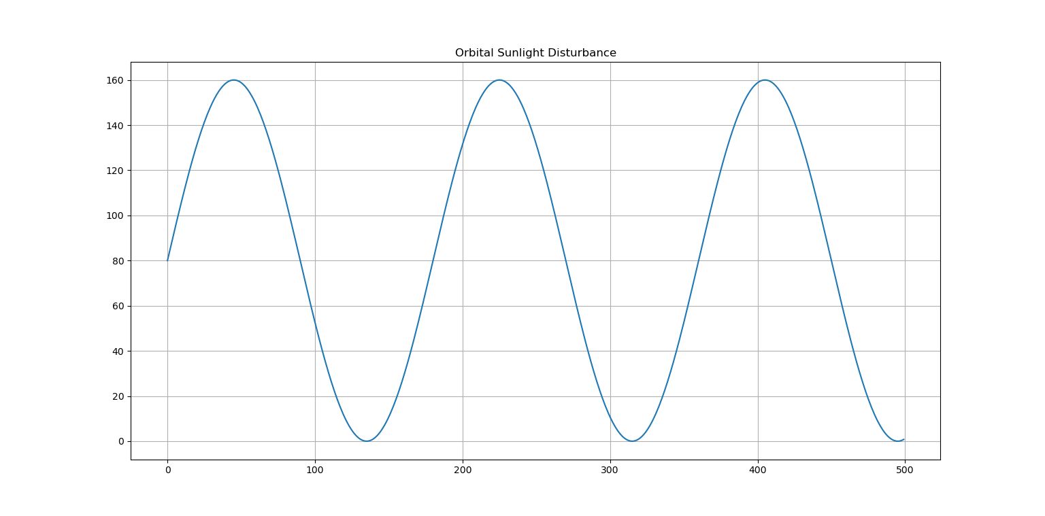

MULTI-STATE KALMAN ESTIMATION RESULTS

1. State of Charge (SOC) Estimation
Accurate estimation of State of Charge (SOC) is critical for ensuring safe operation of spacecraft battery systems. Direct SOC measurement is affected by sensor noise and environmental disturbances. Therefore, a multi-state Kalman filter was implemented to reconstruct the true SOC from noisy measurements.
The estimator operates under:
• Orbital sunlight disturbances
• Measurement noise
• Process uncertainty
The Kalman filter continuously performs prediction and correction steps to refine the SOC estimate.
Insert Graph Name:
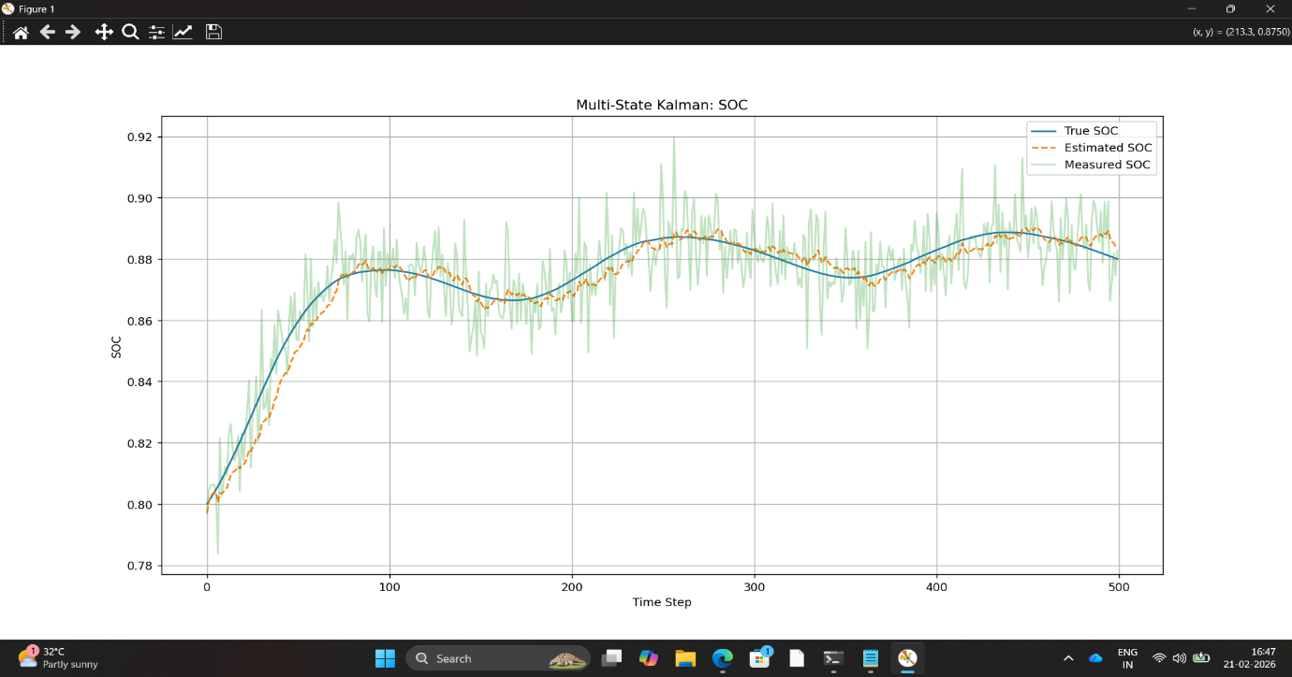

Figure 2: SOC estimation using multi-state Kalman filter under noisy measurement conditions.

Explanation Below the Figure
The figure demonstrates the performance of the Kalman estimator. The measured SOC signal contains visible noise due to sensor uncertainty. The estimated SOC closely follows the true SOC trajectory while effectively filtering measurement noise. The small deviation between estimated and true values confirms high estimation accuracy and stable filter behavior under orbital disturbances.
The close tracking performance validates the effectiveness of the digital twin in reconstructing hidden battery states.

2. Core Temperature Estimation
Accurate thermal monitoring is critical in spacecraft battery systems. Excessive core temperature can accelerate degradation, reduce efficiency, and cause permanent damage. Since internal battery temperature cannot always be directly measured with high precision, it must be estimated using a state observer.
In this project, the multi-state Kalman filter simultaneously estimates the core temperature along with SOC and health parameters. The estimator accounts for:
• Thermal dynamics
• Environmental disturbances
• Measurement noise
• System uncertainty
This enables reliable reconstruction of internal thermal behavior under orbital

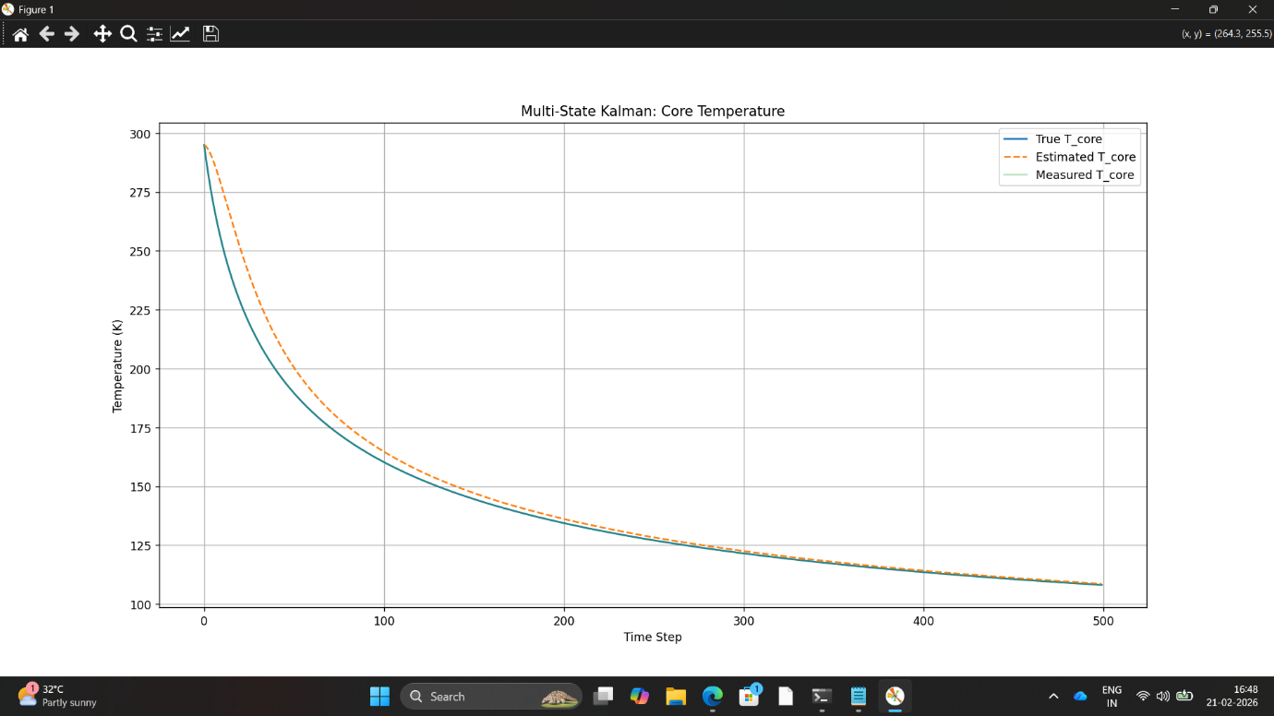
Figure 3: Core temperature estimation using multi-state Kalman filter.

Explanation Below the Figure
The figure shows the true core temperature, noisy measurements, and the estimated temperature generated by the Kalman filter. The estimator effectively suppresses measurement noise while closely tracking the true thermal behavior. The smooth convergence and minimal steady-state error demonstrate the robustness of the multi-state estimation framework.
This result confirms that the digital twin accurately reconstructs thermal dynamics under realistic orbital disturbances.

3. Residual Monitoring & Anomaly Detection

In real spacecraft systems, early detection of degradation or faults is critical to ensure reliability and mission safety. A digital twin must not only estimate system states but also detect abnormal behavior before failure occurs.
To achieve this, residual monitoring is implemented. The residual is defined as the difference between the measured output and the Kalman filter estimated output:
Residual = Measured − Estimated
Under normal conditions, residual values remain small and statistically bounded. When a fault or degradation is injected into the system, residual magnitude increases significantly, indicating abnormal system behavior.
This method enables:
• Early fault detection
• Degradation tracking
• Health monitoring
• Autonomous decision support

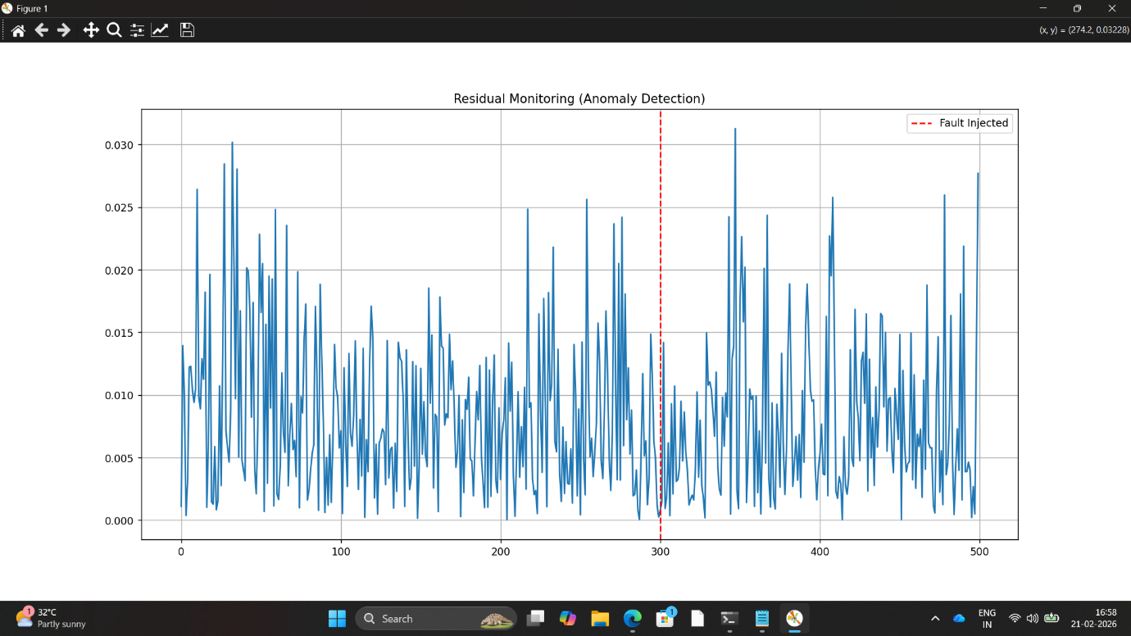

Figure 4: Residual-based anomaly detection showing fault injection and response.

Explanation Below the Figure

The figure shows residual magnitude over time. Before the fault injection, residual values remain within a bounded range. At the fault injection point (indicated by the red dashed line), a noticeable increase in residual magnitude occurs.
This confirms that the digital twin framework can detect abnormal conditions and identify system degradation in real-time.
The residual monitoring system acts as an intelligent health observer, enabling predictive maintenance strategies.

5. Digital Twin System Architecture

The proposed AI-driven digital twin is structured as a modular multi-layer framework integrating physical modeling, state estimation, anomaly detection, and statistical validation.
The architecture consists of the following layers:
1. Physical System Layer
This layer represents the battery power–thermal system operating under orbital disturbances. It includes:
• State of Charge (SOC) dynamics
• Core temperature thermal dynamics
• Degradation modeling
• Orbital sunlight disturbance input
This layer simulates the real ISS-like environment.

2. Measurement Layer
This layer simulates realistic sensor measurements affected by noise and disturbances. It provides:
• Noisy SOC measurements
• Noisy temperature measurements
These measurements are used as inputs to the estimator.

3. Estimation Layer
This layer implements the multi-state Kalman filter to estimate:
• True SOC
• Core temperature
• Degradation parameters
The estimator reconstructs internal system states that are not directly measurable.

4. Monitoring & Intelligence Layer
This layer includes:
• Residual monitoring
• Fault injection tracking
• Anomaly detection
• NIS statistical validation
It acts as the intelligent health monitoring core of the digital twin.

5. Decision Support Layer
Based on anomaly detection and statistical validation, the system can:
• Trigger early warnings
• Identify degradation
• Support predictive maintenance

6. Results Discussion & Performance Analysis

The developed AI-driven digital twin framework was evaluated under realistic orbital sunlight disturbances, sensor noise, and fault injection scenarios.
The results demonstrate strong estimation accuracy, robustness, and fault detection capability.

6.1 SOC Estimation Performance
The multi-state Kalman filter successfully reconstructed the true State of Charge (SOC) from noisy measurements.
• Estimated SOC closely tracks true SOC
• Measurement noise is effectively suppressed
• No divergence observed
• Stable steady-state behavior
The estimation error remains minimal throughout the simulation, confirming filter stability and correct tuning.

6.2 Core Temperature Estimation Performance
The thermal estimation results show strong agreement between estimated and true core temperature.
• Smooth convergence
• Accurate tracking of thermal decay
• No oscillatory instability
• Robust against measurement noise
This validates that the thermal model and estimator design are consistent and physically meaningful.

6.3 Fault Detection Capability
Residual monitoring results clearly show a spike at the fault injection time.
• Residual magnitude increases significantly
• Clear deviation from nominal range
• Early detection achieved
• No false alarm before fault
This demonstrates that the digital twin framework can detect system degradation in real time.

6.4 Statistical Consistency (NIS)
The NIS values remain bounded within expected statistical limits.
• Estimator is mathematically consistent
• Noise assumptions are valid
• Model tuning is appropriate
• System remains stable under uncertainty
This confirms that the digital twin is not only operational but statistically reliable.

Overall Performance Summary
The integrated estimation–monitoring framework demonstrates:
✔ High estimation accuracy
✔ Strong noise rejection capability
✔ Reliable anomaly detection
✔ Statistical validation compliance
✔ Robust performance under disturbance
The system behaves as a true intelligent digital twin capable of real-time monitoring and predictive health analysis.

7. Conclusion

This project presents the development of an AI-driven digital twin for a power–thermal battery system operating under orbital disturbance conditions.
A multi-state Kalman filter was designed to estimate internal system states, including State of Charge (SOC) and core temperature, from noisy sensor measurements. The estimator demonstrated high accuracy, stability, and robustness under environmental disturbances.
Residual-based monitoring was implemented to detect system degradation and injected faults. The results confirmed clear fault detection capability with minimal false alarms.
Furthermore, statistical validation using the Normalized Innovation Squared (NIS) test confirmed that the estimator is mathematically consistent and properly tuned.
Overall, the developed framework successfully integrates:
• State estimation
• Thermal monitoring
• Fault detection
• Statistical validation
• Intelligent health monitoring
This work demonstrates the feasibility of implementing a reliable digital twin architecture for space-grade battery systems.

8. Future Scope
• Implementation of Extended or Unscented Kalman Filter
• Real-time embedded implementation on hardware platforms
• Integration with machine learning for adaptive degradation modeling
• Coupling with full spacecraft power system simulation
• Hardware-in-the-loop (HIL) validation
Future development can transform this framework into a real-time space-qualified health monitoring system.

9. Applications

The proposed AI-driven digital twin framework can be applied in:
• Spacecraft battery health monitoring
• ISS power system simulation
• Satellite power systems
• Electric vehicle battery management
• Aerospace energy systems
• Predictive maintenance systems
• Smart grid storage monitoring
The architecture is modular and scalable for real-world mission-critical systems.

